 | European Journal of Chemistry  Journal homepage: www.eurjchem.com
Structural and electronic effects of the C2’ substituent in 1,4–benzodiazepines
Lígia Rebelo Gomes^{a,b}, Luís Manuel Neves Belchior Faia Santos^{c},
José Belezaª and John Nicolson Low^{d,}*
ª CIAGEB-Faculdade de Ciências de Saúde, Escola Superior de Saúde da UFP, Universidade Fernando Pessoa, Porto, P-4200-150, Portugal
^{b} REQUIMTE, Departamento de Química e Bioquímica, Faculdade de Ciências, Universidade do Porto, Porto, P-4169-007, Portugal
^{c} Centro de Investigação em Química, Departamento de Química e Bioquímica, Faculdade de Ciências, Universidade do Porto, Porto, P-4169-007, Portugal
^{d} Department of Chemistry, University of Aberdeen, AB24 3UE, Scotland

*Corresponding author at: Department of Chemistry, University of Aberdeen, AB24 3UE, Scotland. Tel.: +441382542709; fax: +441382542709.
E-mail address: jnlow111@gmail.com (J.N. Low).

ARTICLE INFORMATION |  |  | ABSTRACT
Received: 17 November 2010  Received in revised form: 08 January 2011  Accepted: 11 January 2011  Online: 31 March 2011  KEYWORDS |  |  | Benzodiazepines are drugs used for treatment of several central nervous system disorders, such as anxiety and sleep. In spite of their wide and popular usage in clinics, the mechanism explaining why a certain pharmacological activity is superimposed onto another for a given benzodiazepine remains unclear. The knowledge of the conformation of benzodiazepines and their electronic charge distribution at molecular surfaces may give new insights into the pharmaco-benzodiazepine receptor interactions, contributing to the improvement of the existing models. In the present study, the solid state geometric and conformational parameters of the available X-ray benzodiazepine structures were analyzed and reviewed. The electronic features of two groups of benzodiazepines with different substituents at C₇ and C₂’ positions were studied by DFT quantum chemical calculations. The conformations of the molecules with optimized geometry were also analyzed. The relative charge distribution around the benzodiazepinic rings and electrostatic potential mapped on electronic density surfaces were obtained. The ring geometric parameters for the diazepine moiety in 1,4-benzodiazepines, do not vary significantly except for a few compounds in which steric and/or intermolecular interactions play a part. The benzodiazepine ring assumes a pseudo-symmetrical boat conformation and the torsion angle around the C₅-Ph bond varies depending on the nature of the substituent on C₂’. Also, the presence of the nitro or chloride substituent on the C₇ position and the presence of a fluorine atom on the C₂’ position significantly alter the relative charge distributions at the attached carbon atoms and the topology of the surface electrostatic potential.
Benzodiazepine
DFT
Structure characterization
X-ray
Fluoro
Isoelectronic potential surfaces

Supplementary Information

Geometric optimizations drawing and atomic coordinates for Compounds

# Geom optimization and atomic coordinates for diazepan_1
# Created by GaussView 3.07

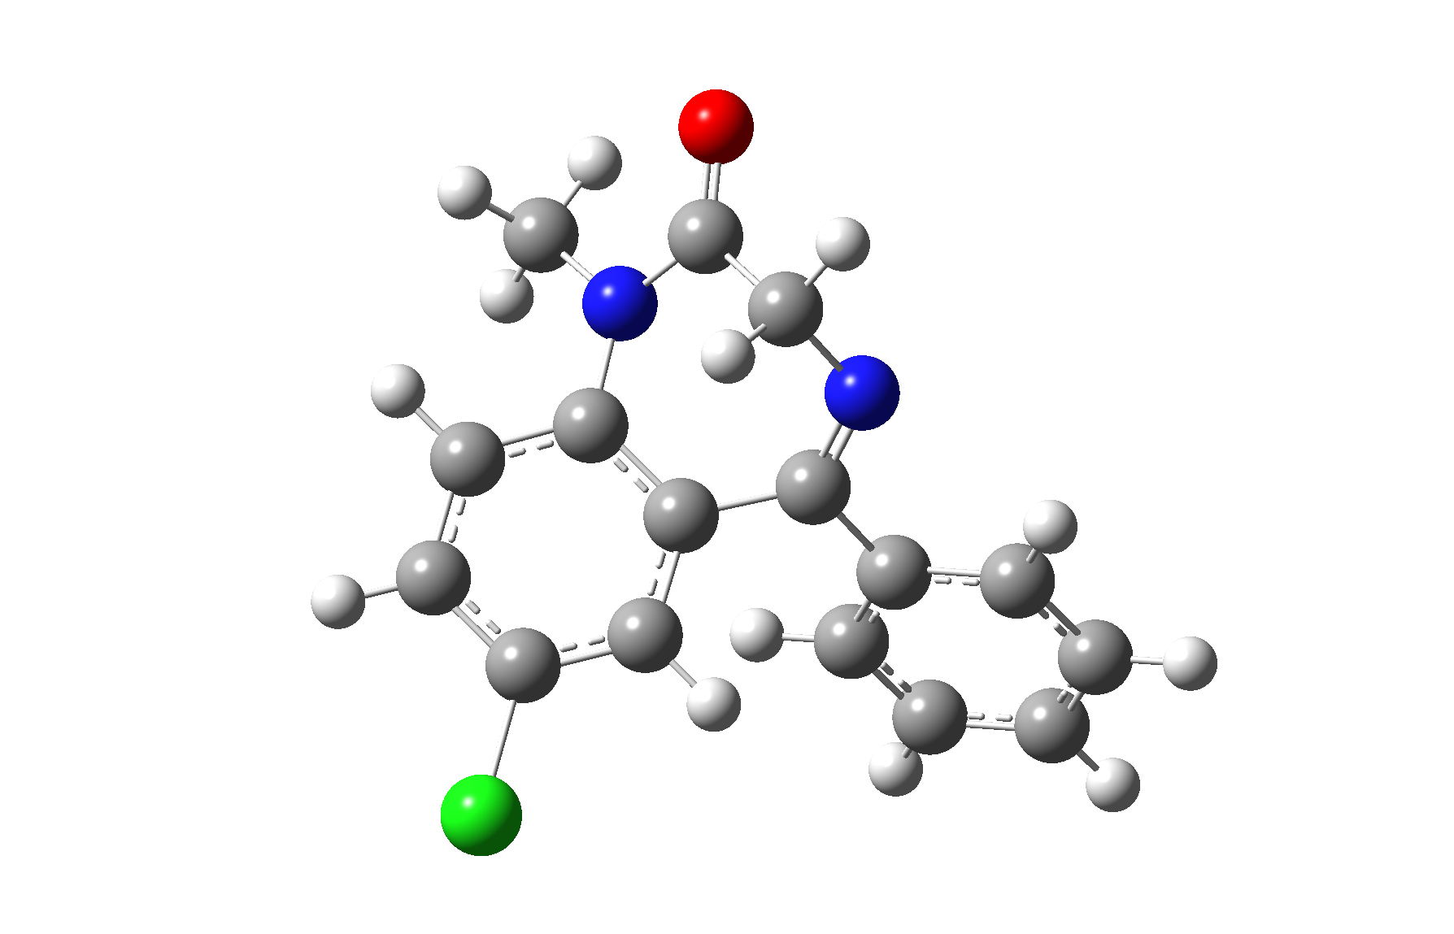
 | x | y | z
C | -0.414800 | 0.215700 | -0.215200
C | 0.611100 | -0.833700 | -0.486600
N | 0.349400 | -1.939600 | -1.090200
C | -1.014000 | -2.190600 | -1.532500
C | -1.913000 | -2.490800 | -0.336600
N | -2.091700 | -1.439600 | 0.558000
C | -1.705300 | -0.106400 | 0.270800
C | -2.617200 | 0.935100 | 0.523300
C | -2.288100 | 2.263700 | 0.280100
C | -1.023900 | 2.569100 | -0.227700
C | -0.096600 | 1.563200 | -0.464500
C | 2.022300 | -0.594300 | -0.059700
C | 2.329500 | 0.186400 | 1.067200
C | 3.654600 | 0.355400 | 1.475100
C | 4.691400 | -0.244600 | 0.757200
C | 4.395300 | -1.023800 | -0.366800
C | 3.073100 | -1.201600 | -0.769200
O | -2.430500 | -3.582400 | -0.152100
C | -2.966300 | -1.701200 | 1.708100
H | -1.027100 | -3.076800 | -2.166500
H | -1.430000 | -1.340900 | -2.097000
H | -3.606400 | 0.700300 | 0.899500
H | -3.008300 | 3.051900 | 0.469400
H | 0.887500 | 1.815800 | -0.842300
H | 1.532200 | 0.650100 | 1.639200
H | 3.874300 | 0.954200 | 2.354200
H | 5.722400 | -0.107600 | 1.070400
H | 5.197100 | -1.492200 | -0.930400
H | -2.802700 | -2.729000 | 2.030900
H | -4.027000 | -1.594200 | 1.451800
Cl | 4.240900 | -0.562100 | 1.451800
H | -2.711600 | -1.011700 | 2.514400
H | 2.832500 | -1.813200 | -1.631800

# Geom optimization and atomic coordinates for Flurazepam_1
# Created by GaussView 3.07
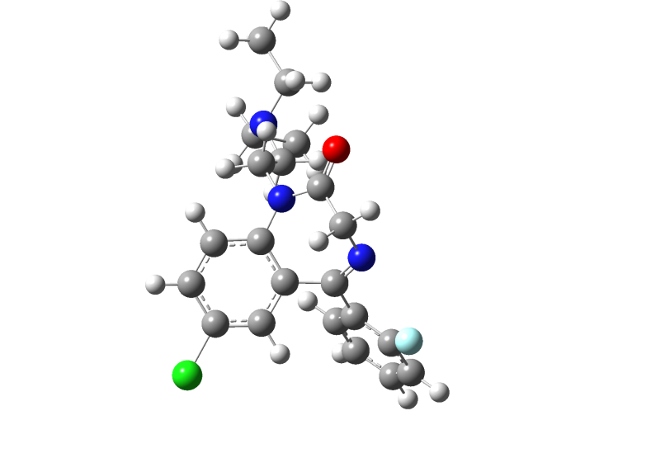

 | x | y | z
C1 | -1.2690 | 0.8076 | 0.4190
C2 | -1.4999 | -0.5849 | 0.9007
N3 | -1.1151 | -1.0275 | 2.0428
C4 | -0.4068 | -0.1205 | 2.9377
C5 | 1.0026 | 0.1214 | 2.4062
N6 | 1.0809 | 0.8614 | 1.2326
C7 | -0.0438 | 1.4869 | 0.6292
C8 | 0.0706 | 2.8204 | 0.1927
C9 | -0.9764 | 3.4716 | -0.4475
C10 | -2.1759 | 2.7879 | -0.6597
C11 | -2.3216 | 1.4754 | -0.2350
C12 | -2.2400 | -1.5205 | 0.0005
C13 | -1.9035 | -1.6228 | -1.3608
C14 | -2.5397 | -2.5316 | -2.2053
C15 | -3.5516 | -3.3549 | -1.7029
C16 | -3.9235 | -3.2629 | -0.3610
C17 | -3.2656 | -2.3563 | 0.4631
O18 | 2.0000 | -0.3319 | 2.9504
F19 | -3.6796 | -2.2691 | 1.7478
C20 | 2.4269 | 1.0188 | 0.6415
C21 | 2.7850 | -0.1606 | -0.2816
N22 | 4.1577 | -0.0274 | -0.7704
C23 | 4.3326 | -0.4300 | -2.1719
C24 | 5.1413 | -0.5911 | 0.1658
C25 | 6.5665 | -0.0883 | -0.0699
C26 | 4.1419 | -1.9224 | -2.5004
H27 | -0.3053 | -0.5928 | 3.9141
H28 | -0.9365 | 0.8374 | 3.0526
H29 | 0.9909 | 3.3640 | 0.3729
H30 | -0.8686 | 4.5021 | -0.7674
H31 | -3.2572 | 0.9544 | -0.4039
H32 | -1.1197 | -0.9815 | -1.7523
H33 | -2.2484 | -2.5958 | -3.2488
H34 | -4.0564 | -4.0632 | -2.3527
H35 | -4.7149 | -3.8752 | 0.0577
H36 | 3.1409 | 1.0903 | 1.4624
H37 | 2.4708 | 1.9429 | 0.0670
H38 | 2.1004 | -0.1505 | -1.1374
H39 | 2.6139 | -1.1062 | 0.2577
H40 | 5.3318 | -0.1151 | -2.4911
H41 | 3.6275 | 0.1628 | -2.7675
H42 | 5.1295 | -1.6965 | 0.1532
H43 | 4.8311 | -0.3035 | 1.1749
H44 | 7.2266 | -0.4600 | 0.7211
H45 | 6.5957 | 1.0063 | -0.0597
H46 | 6.9782 | -0.4309 | -1.0248
H47 | 4.2704 | -2.0848 | -3.5766
H48 | 3.1405 | -2.2746 | -2.2284
H49 | 4.8711 | -2.5542 | -1.9831
Cl50 | -3.5095 | 3.5999 | -1.4630

# Geom optimization and atomic coordinates for Desalkylflurazepam_1
# Created by GaussView 3.07
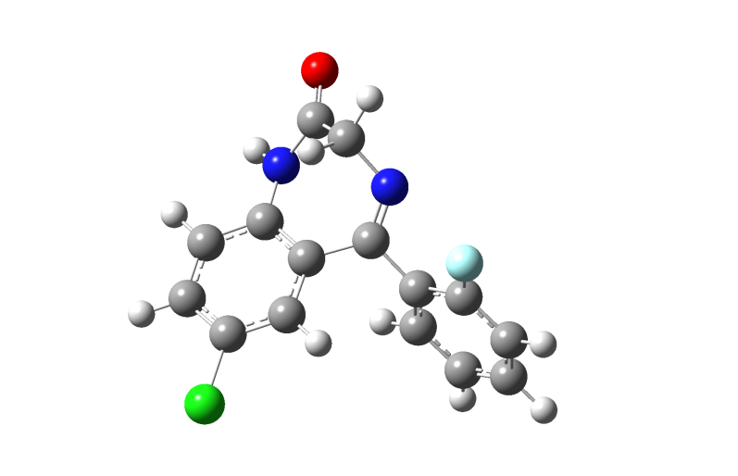

 | x | y | z
C1 | 0.7638 | 0.0452 | -0.0666
C2 | -0.5034 | 0.8195 | -0.2054
N3 | -0.5962 | 2.0351 | -0.6068
C4 | 0.5998 | 2.7394 | -1.0459
C5 | 1.5110 | 3.0826 | 0.1264
N6 | 2.0240 | 1.9849 | 0.8041
C7 | 1.9517 | 0.6328 | 0.4288
C8 | 3.0912 | -0.1690 | 0.6206
C9 | 3.0819 | -1.5224 | 0.3096
C10 | 1.9156 | -2.0925 | -0.2096
C11 | 0.7715 | -1.3267 | -0.3837
C12 | -1.7744 | 0.1299 | 0.1808
C13 | -1.8923 | -0.5266 | 1.4180
C14 | -3.0910 | -1.1147 | 1.8201
C15 | -4.2031 | -1.0735 | 0.9740
C16 | -4.1114 | -0.4467 | -0.2696
C17 | -2.9083 | 0.1430 | -0.6412
O18 | 1.7938 | 4.2181 | 0.4683
F19 | -2.8432 | 0.7123 | -1.8676
H20 | 0.3083 | 3.6795 | -1.5133
H21 | 1.1759 | 2.1430 | -1.7718
H22 | 3.9982 | 0.2847 | 1.0103
H23 | 3.9696 | -2.1275 | 0.4561
H24 | -0.1333 | -1.7891 | -0.7612
H25 | -1.0290 | -0.5586 | 2.0759
H26 | -3.1566 | -1.6018 | 2.7877
H27 | -5.1397 | -1.5319 | 1.2762
H28 | -4.9506 | -0.4090 | -0.9558
Cl29 | 1.8976 | -3.7967 | -0.6324
H30 | 2.7266 | 2.2368 | 1.4901

# Geom optimization and atomic coordinates for Hydroxyethylflurazepam_1
# Created by GaussView 3.07

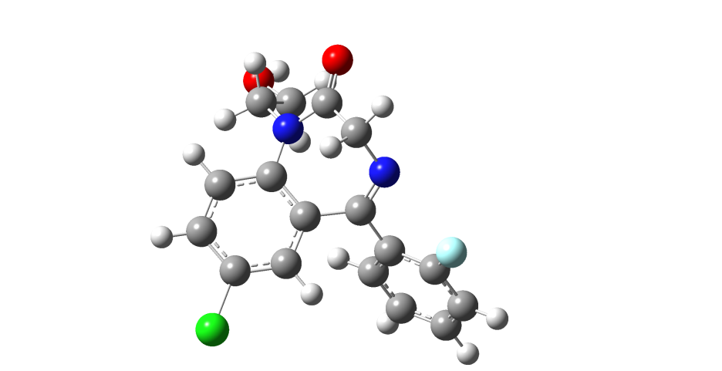
 | x | y | z
C1 | -0.0107 | 0.6363 | -0.4020
C2 | 0.6337 | -0.6850 | -0.6544
N3 | 0.2043 | -1.5443 | -1.5065
C4 | -2.2173 | -1.2971 | -1.3902
N5 | -2.3011 | -0.3252 | -0.3989
C6 | -1.4162 | 0.7860 | -0.3250
C7 | -1.9502 | 2.0749 | -0.1410
C8 | -1.1321 | 3.1912 | -0.0176
C9 | 0.2540 | 3.0307 | -0.0836
C10 | 0.8090 | 1.7729 | -0.2709
C11 | 1.8605 | -1.0225 | 0.1286
C12 | 1.9070 | -0.8036 | 1.5170
C13 | 3.0179 | -1.1651 | 2.2779
C14 | 4.1272 | -1.7441 | 1.6547
C15 | 4.1208 | -1.9552 | 0.2752
C16 | 2.9960 | -1.5964 | -0.4596
O17 | -3.0613 | -2.1749 | -1.4996
F18 | 3.0421 | -1.7820 | -1.7984
C19 | -3.4408 | -0.4329 | 0.5320
C20 | -3.1904 | -1.4952 | 1.6043
H21 | -3.0256 | 2.2088 | -0.1104
H22 | -1.5643 | 4.1768 | 0.1158
H23 | 1.8860 | 1.6600 | -0.3208
H24 | 1.0473 | -0.3505 | 2.0016
H25 | 3.0182 | -0.9946 | 3.3497
H26 | 4.9992 | -2.0254 | 2.2369
H27 | 4.9705 | -2.3875 | -0.2422
H28 | -4.3403 | -0.6886 | -0.0314
H29 | -3.5950 | 0.5256 | 1.0262
H30 | -2.2388 | -1.2888 | 2.1164
H31 | -3.1345 | -2.4846 | 1.1378
C32 | -0.9846 | -1.2176 | -2.2848
H33 | -1.1103 | -1.9615 | -3.0707
Cl34 | 1.2999 | 4.4329 | 0.0651
O35 | -4.2854 | -1.4073 | 2.5169
H36 | -4.3256 | -2.2122 | 3.0471
H37 | -0.9144 | -0.2183 | -2.7406

# Geom optimization and atomic coordinates for Nitrozepam_1
# Created by GaussView 3.07

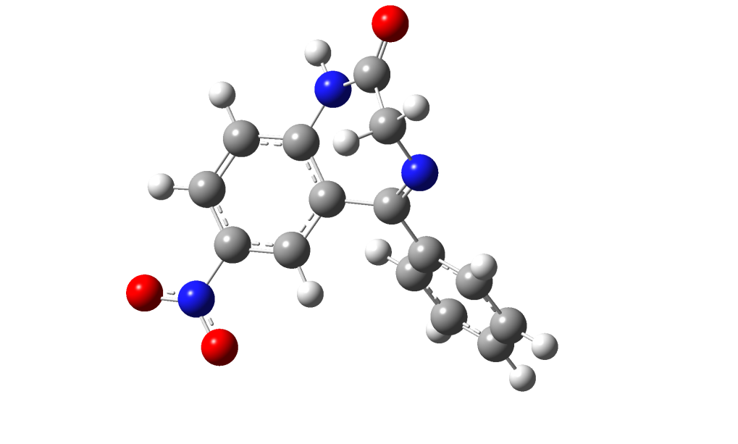

 | x | y | z
C1 | 0.3524 | 0.4623 | -0.0991
C2 | -1.1200 | 0.5259 | -0.3508
N3 | -1.7322 | 1.5486 | -0.8349
C4 | -0.9717 | 2.7279 | -1.2172
C5 | -0.4582 | 3.4728 | 0.0084
N6 | 0.4475 | 2.7578 | 0.7925
C7 | 1.0642 | 1.5431 | 0.4813
C8 | 2.4279 | 1.3908 | 0.8081
C9 | 3.1052 | 0.2170 | 0.5249
C10 | 2.4087 | -0.8215 | -0.1008
C11 | 1.0555 | -0.7152 | -0.3951
C12 | -1.9464 | -0.6741 | -0.0204
C13 | -1.6248 | -1.5193 | 1.0550
C14 | -2.4426 | -2.6052 | 1.3740
C15 | -3.5856 | -2.8682 | 0.6160
C16 | -3.9137 | -2.0328 | -0.4572
C17 | -3.1053 | -0.9415 | -0.7696
O18 | -0.7751 | 4.6082 | 0.3107
N19 | 3.1195 | -2.0619 | -0.4357
O20 | 4.3087 | -2.1415 | -0.1189
O21 | 2.4885 | -2.9501 | -1.0114
H22 | -1.6213 | 3.4144 | -1.7597
H23 | -0.1098 | 2.4743 | -1.8563
H24 | 0.8886 | 3.3323 | 1.5024
H25 | 2.9561 | 2.2197 | 1.2698
H26 | 4.1555 | 0.0984 | 0.7603
H27 | 0.5453 | -1.5572 | -0.8459
H28 | -0.7456 | -1.3208 | 1.6599
H29 | -2.1857 | -3.2432 | 2.2143
H30 | -4.2168 | -3.7181 | 0.8587
H31 | -4.8001 | -2.2334 | -1.0518
H32 | -3.3580 | -0.2816 | -1.5923

# Geom optimization and atomic coordinates for Clonazepam_1
# Created by GaussView 3.07

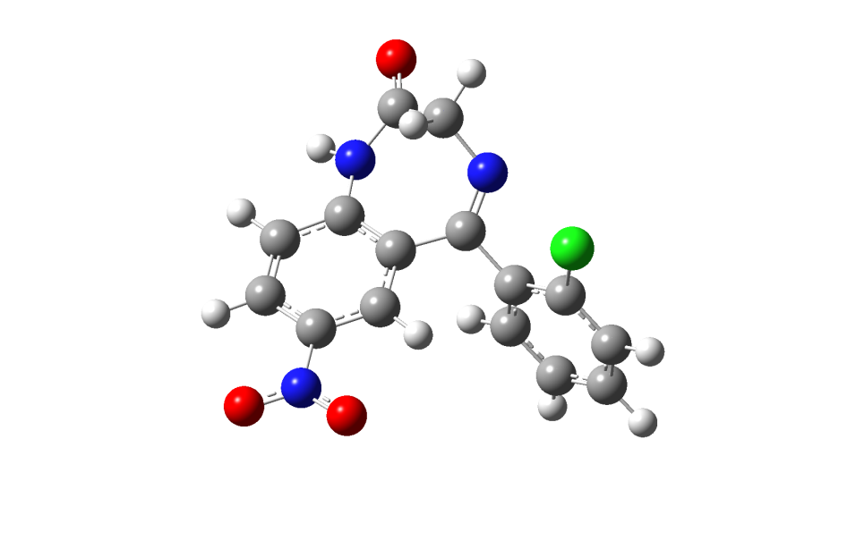

 | x | y | z
C1 | 0.7536 | 0.3929 | 0.0141
C2 | -0.6607 | 0.8635 | -0.0286
N3 | -1.0625 | 2.0130 | -0.4259
C4 | -0.1061 | 2.9566 | -0.9877
C5 | 0.8240 | 3.5244 | 0.0743
N6 | 1.6473 | 2.5901 | 0.7017
C7 | 1.8287 | 1.2423 | 0.3839
C8 | 3.1289 | 0.7093 | 0.5121
C9 | 3.3862 | -0.6260 | 0.2544
C10 | 2.3246 | -1.4477 | -0.1371
C11 | 1.0297 | -0.9597 | -0.2407
C12 | -1.7085 | -0.0886 | 0.4718
C13 | -1.6705 | -0.4991 | 1.8146
C14 | -2.6520 | -1.3310 | 2.3495
C15 | -3.6894 | -1.7871 | 1.5326
C16 | -3.7380 | -1.4123 | 0.1902
C17 | -2.7552 | -0.5680 | -0.3321
N18 | 2.5822 | -2.8653 | -0.4222
O19 | 0.8916 | 4.7023 | 0.3730
Cl20 | -2.8440 | -0.1726 | -2.0421
O21 | 3.7389 | -3.2720 | -0.2903
O22 | 1.6306 | -3.5642 | -0.7736
H23 | -0.6473 | 3.7967 | -1.4217
H24 | 0.5072 | 2.4854 | -1.7724
H25 | 2.3584 | 3.0251 | 1.2795
H26 | 3.9414 | 1.3670 | 0.8067
H27 | 4.3841 | -1.0372 | 0.3417
H28 | 0.2296 | -1.6378 | -0.5108
H29 | -0.8621 | -0.1423 | 2.4466
H30 | -2.6060 | -1.6221 | 3.3941
H31 | -4.4583 | -2.4402 | 1.9337
H32 | -4.5289 | -1.7725 | -0.4583

# Geom optimization and atomic coordinates for Flunitrazepam_1
# Created by GaussView 3.07

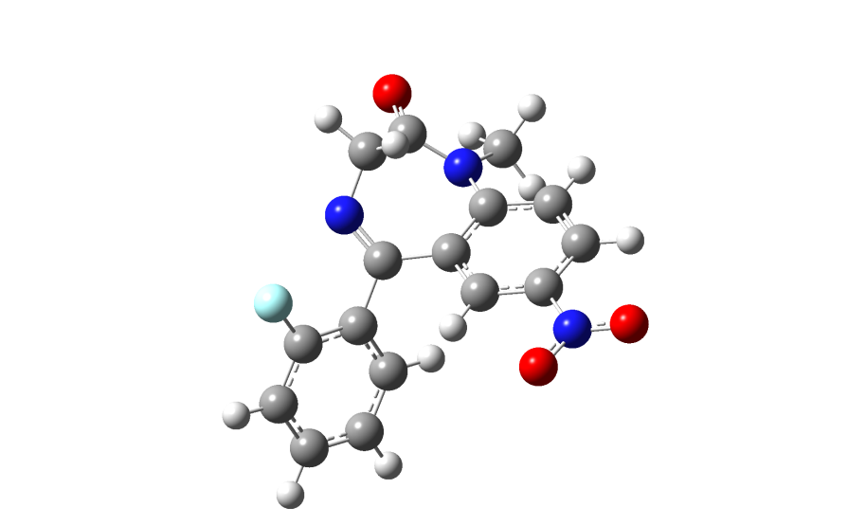

 | x | y | z
C1 | 2.7837 | 1.6531 | 0.1990
C2 | 1.5496 | 2.1722 | -0.1977
C3 | 0.4412 | 1.3526 | -0.3618
C4 | 0.5407 | -0.0308 | -0.1552
C5 | 1.7935 | -0.5787 | 0.2345
C6 | 2.8934 | 0.2888 | 0.4155
N7 | 1.4171 | 3.6158 | -0.4316
C8 | -0.6818 | -0.8691 | -0.3246
N9 | -0.6985 | -2.0226 | -0.8859
C10 | 0.5451 | -2.5463 | -1.4318
C11 | 1.4878 | -2.9735 | -0.3146
N12 | 1.9628 | -1.9491 | 0.5131
C13 | -1.9713 | -0.3235 | 0.1968
C14 | -2.0529 | 0.2220 | 1.4902
C15 | -3.2601 | 0.6830 | 2.0129
C16 | -4.4207 | 0.6232 | 1.2360
C17 | -4.3689 | 0.1043 | -0.0583
C18 | -3.1552 | -0.3601 | -0.5524
F19 | -3.1340 | -0.8234 | -1.8228
O20 | 1.8179 | -4.1332 | -0.1326
C21 | 2.9201 | -2.3566 | 1.5526
O22 | 0.3184 | 4.0428 | -0.7905
O23 | 2.4158 | 4.3167 | -0.2526
H24 | 3.6333 | 2.3131 | 0.3228
H25 | -0.5067 | 1.7946 | -0.6430
H26 | 3.8518 | -0.1195 | 0.7122
H27 | 1.0516 | -1.8107 | -2.0763
H28 | 0.3288 | -3.4386 | -2.0182
H29 | -1.1523 | 0.2687 | 2.0953
H30 | -3.2946 | 1.0875 | 3.0193
H31 | -5.3646 | 0.9852 | 1.6318
H32 | -5.2475 | 0.0579 | -0.6927
H33 | 2.6239 | -3.3412 | 1.9119
H34 | 2.8899 | -1.6357 | 2.3706
H35 | 3.9413 | -2.4335 | 1.1623

# Geom optimization and atomic coordinates for Desmethylflunitrazepam_1
# Created by GaussView 3.07

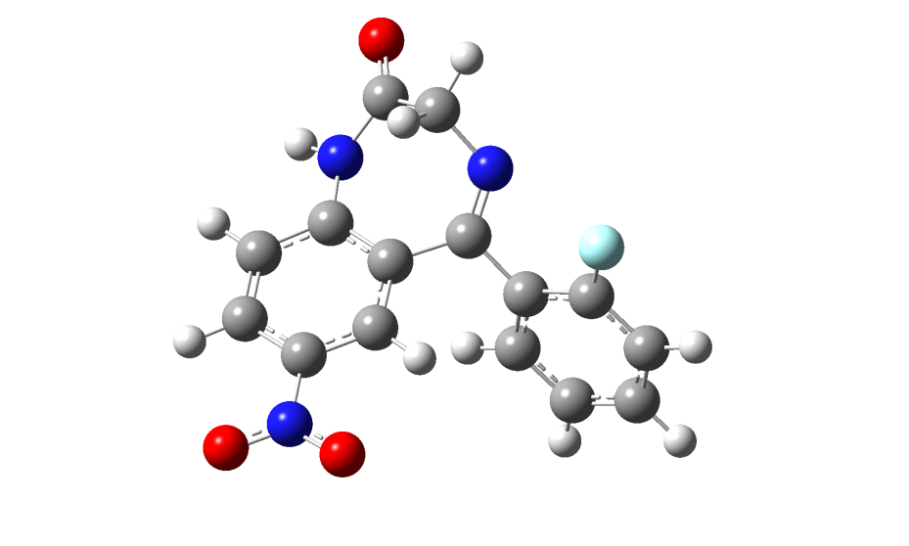

 | x | y | z
C1 | 0.5734 | 0.4382 | -0.0539
C2 | -0.8842 | 0.7275 | -0.1977
N3 | -1.3902 | 1.8296 | -0.6162
C4 | -0.5122 | 2.8935 | -1.0803
C5 | 0.2378 | 3.5470 | 0.0718
N6 | 1.1099 | 2.7048 | 0.7619
C7 | 1.4937 | 1.4036 | 0.4304
C8 | 2.8380 | 1.0384 | 0.6552
C9 | 3.2901 | -0.2399 | 0.3773
C10 | 2.3835 | -1.1729 | -0.1355
C11 | 1.0475 | -0.8526 | -0.3344
C12 | -1.8358 | -0.3546 | 0.2041
C13 | -1.7182 | -0.9961 | 1.4494
C14 | -2.6366 | -1.9608 | 1.8611
C15 | -3.6916 | -2.3200 | 1.0170
C16 | -3.8238 | -1.7148 | -0.2335
C17 | -2.9023 | -0.7463 | -0.6151
N18 | 2.8509 | -2.5289 | -0.4503
O19 | 0.1298 | 4.7162 | 0.3915
F20 | -3.0373 | -0.2028 | -1.8469
O21 | 4.0351 | -2.7899 | -0.2264
O22 | 2.0351 | -3.3258 | -0.9167
H23 | -1.1121 | 3.6700 | -1.5541
H24 | 0.2258 | 2.5207 | -1.8088
H25 | 1.7056 | 3.2088 | 1.4098
H26 | 3.5296 | 1.7825 | 1.0392
H27 | 4.3233 | -0.5221 | 0.5372
H28 | 0.3702 | -1.6155 | -0.6977
H29 | -0.9000 | -0.7169 | 2.1067
H30 | -2.5288 | -2.4302 | 2.8335
H31 | -4.4083 | -3.0745 | 1.3262
H32 | -4.6216 | -1.9816 | -0.9181

# Geom optimization and atomic coordinates for Nitroflurazepam_1
# Created by GaussView 3.07

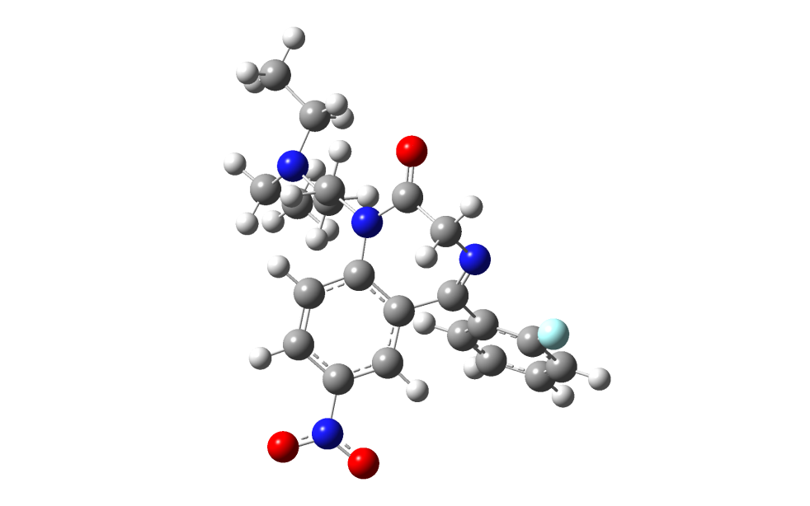

 | x | y | z
C1 | 1.0970 | 0.4401 | -0.7035
C2 | 1.4964 | -0.9964 | -0.7629
N3 | 1.2367 | -1.7767 | -1.7478
C4 | 0.5133 | -1.2280 | -2.8872
C5 | -0.9461 | -1.0089 | -2.5076
N6 | -1.1877 | 0.0246 | -1.5933
C7 | -0.1792 | 0.9005 | -1.1301
C8 | -0.4690 | 2.2797 | -1.0350
C9 | 0.4598 | 3.1879 | -0.5540
C10 | 1.7094 | 2.7171 | -0.1452
C11 | 2.0256 | 1.3677 | -0.2080
C12 | 2.2579 | -1.5542 | 0.3945
C13 | 1.8360 | -1.3179 | 1.7149
C14 | 2.4984 | -1.8797 | 2.8052
C15 | 3.6215 | -2.6849 | 2.5948
C16 | 4.0768 | -2.9229 | 1.2974
C17 | 3.3919 | -2.3608 | 0.2260
O18 | -1.8473 | -1.6984 | -2.9562
F19 | 3.8826 | -2.5829 | -1.0141
C20 | -2.5929 | 0.2563 | -1.1946
C21 | -2.8201 | -0.0134 | 0.3028
N22 | -4.2300 | 0.1597 | 0.6462
C23 | -4.4484 | 0.7530 | 1.9733
C24 | -5.0308 | -1.0407 | 0.3644
C25 | -6.5356 | -0.7739 | 0.3048
C26 | -4.0446 | -0.0972 | 3.1915
N27 | 2.7049 | 3.6661 | 0.3692
O28 | 2.3790 | 4.8535 | 0.4374
O29 | 3.8047 | 3.2226 | 0.7044
H30 | 0.5246 | -1.9540 | -3.6991
H31 | 0.9566 | -0.2849 | -3.2414
H32 | -1.4339 | 2.6464 | -1.3609
H33 | 0.2363 | 4.2462 | -0.5002
H34 | 2.9977 | 1.0352 | 0.1346
H35 | 0.9637 | -0.6926 | 1.8800
H36 | 2.1417 | -1.6889 | 3.8123
H37 | 4.1482 | -3.1227 | 3.4371
H38 | 4.9540 | -3.5297 | 1.1003
H39 | -3.1873 | -0.4210 | -1.8049
H40 | -2.9074 | 1.2738 | -1.4374
H41 | -2.2279 | 0.6986 | 0.8882
H42 | -2.4381 | -1.0210 | 0.5457
H43 | -5.5072 | 1.0199 | 2.0527
H44 | -3.8983 | 1.7015 | 1.9956
H45 | -4.8242 | -1.8477 | 1.0916
H46 | -4.7099 | -1.4255 | -0.6085
H47 | -7.0588 | -1.6791 | -0.0210
H48 | -6.7573 | 0.0284 | -0.4065
H49 | -6.9498 | -0.4917 | 1.2779
H50 | -4.2280 | 0.4647 | 4.1141
H51 | -2.9811 | -0.3599 | 3.1689
H52 | -4.6190 | -1.0271 | 3.2525

# Geom optimization and atomic coordinates for Desalkylnitroflurazepam_1
# Created by GaussView 3.07
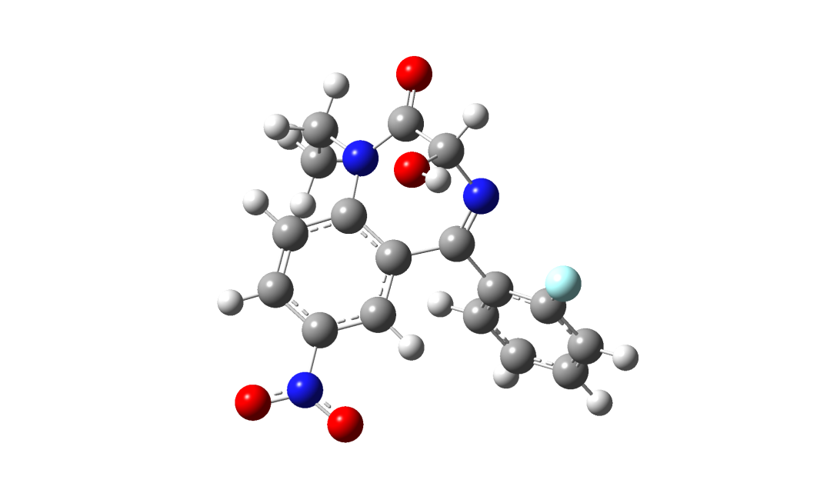
 | x | y | z
C1 | -0.3204 | 0.2452 | -0.1876
C2 | 0.5681 | -0.9446 | -0.3075
N3 | 0.2592 | -2.0572 | -0.8718
C4 | -2.1241 | -2.2556 | -0.4156
N5 | -2.3729 | -1.0790 | 0.2940
C6 | -1.7171 | 0.1498 | 0.0653
C7 | -2.4687 | 1.3400 | 0.1548
C8 | -1.8884 | 2.5868 | -0.0137
C9 | -0.5172 | 2.6599 | -0.2606
C10 | 0.2597 | 1.5120 | -0.3349
C11 | 1.9379 | -0.8413 | 0.2824
C12 | 2.1243 | -0.3849 | 1.5991
C13 | 3.3887 | -0.3508 | 2.1850
C14 | 4.5064 | -0.7565 | 1.4498
C15 | 4.3562 | -1.1942 | 0.1332
C16 | 3.0830 | -1.2336 | -0.4230
N17 | 0.1175 | 3.9706 | -0.4348
O18 | -2.7149 | -3.2978 | -0.1822
F19 | 2.9754 | -1.6284 | -1.7137
C20 | -3.4714 | -1.1367 | 1.2909
C21 | -2.9987 | -0.8271 | 2.7111
O22 | -0.5977 | 4.9702 | -0.3315
O23 | 1.3271 | 3.9992 | -0.6718
H24 | -3.5338 | 1.2875 | 0.3380
H25 | -2.4789 | 3.4931 | 0.0367
H26 | 1.3232 | 1.6069 | -0.5143
H27 | 1.2569 | -0.0682 | 2.1703
H28 | 3.5016 | -0.0067 | 3.2080
H29 | 5.4959 | -0.7262 | 1.8953
H30 | 5.2044 | -1.4996 | -0.4697
H31 | -3.8586 | -2.1525 | 1.2338
H32 | -4.2808 | -0.4664 | 0.9860
H33 | -3.8434 | -0.9173 | 3.4018
H34 | -2.5961 | 0.1860 | 2.8051
H35 | -2.2278 | -1.5380 | 3.0241
C36 | -1.0441 | -2.2039 | -1.5024
H37 | -1.0646 | -3.1834 | -1.9846
O38 | -1.3833 | -1.1858 | -2.4363
H39 | -0.7986 | -1.2732 | -3.2019

Parameter Values for bond lengths and angles of the Rx-structures

Parameter Values for bond lengths
Refcode | C2-C3 |  |  | C2-O2 | C3-N4 | C5-C11 | C5-C1' | C10-C11 | N1-C2 | N1-C10 | N4-C5
BAZCLH | 1,444 |  |  | 1,328 | 1,427 | 1,448 | 1,556 | 1,33 | 1,308 | 1,428 | 1,277
BCHBZP | 1,507 |  |  | 1,215 | 1,472 | 1,487 | 1,492 | 1,406 | 1,378 | 1,414 | 1,284
BEDZPN10 | 1,507 |  |  | 1,227 | 1,474 | 1,501 | 1,487 | 1,406 | 1,394 | 1,432 | 1,289
BIZSAE | 1,506 |  |  | 1,224 | 1,472 | 1,486 | 1,500 | 1,397 | 1,377 | 1,424 | 1,277
BOFDEF | 1,536 |  |  | 1,221 | 1,47 | 1,496 | 1,500 | 1,403 | 1,364 | 1,418 | 1,285
BOMMUL | 1,536 |  |  | 1,213 | 1,446 | 1,500 | 1,490 | 1,394 | 1,373 | 1,412 | 1,269
BORXEL | 1,503 |  |  | 1,272 | 1,475 | 1,447 | 1,499 | 1,393 | 1,333 | 1,401 | 1,308
BORXEL | 1,498 |  |  | 1,211 | 1,492 | 1,502 | 1,460 | 1,374 | 1,372 | 1,4 | 1,286
BORXEL | 1,495 |  |  | 1,239 | 1,516 | 1,491 | 1,492 | 1,366 | 1,337 | 1,442 | 1,245
CAGWUC | 1,499 |  |  | 1,197 | 1,448 | 1,479 | 1,483 | 1,399 | 1,372 | 1,414 | 1,286
CHABZN | 1,507 |  |  | 1,226 | 1,477 | 1,491 | 1,500 | 1,406 | 1,368 | 1,416 | 1,281
CICSEM | 1,501 |  |  | 1,212 | 1,492 | 1,479 | 1,475 | 1,394 | 1,367 | 1,426 | 1,315
CLDZPA | 1,497 |  |  | 1,25 | 1,474 | 1,519 | 1,479 | 1,395 | 1,342 | 1,378 | 1,295
CLDZPB | 1,508 |  |  | 1,224 | 1,47 | 1,483 | 1,504 | 1,405 | 1,372 | 1,425 | 1,28
CPHAZO | 1,521 |  |  | 1,236 | 1,475 | 1,479 | 1,478 | 1,407 | 1,353 | 1,401 | 1,28
CPHAZO | 1,501 |  |  | 1,24 | 1,446 | 1,471 | 1,493 | 1,378 | 1,313 | 1,406 | 1,272
CPHNZP | 1,506 |  |  | 1,233 | 1,457 | 1,484 | 1,498 | 1,408 | 1,356 | 1,41 | 1,284
CPHNZP | 1,507 |  |  | 1,229 | 1,471 | 1,485 | 1,507 | 1,407 | 1,362 | 1,399 | 1,281
DCDAZP | 1,513 |  |  | 1,221 | 1,462 | 1,487 | 1,490 | 1,400 | 1,363 | 1,428 | 1,281
DIZPAM10 | 1,505 |  |  | 1,218 | 1,461 | 1,48 | 1,493 | 1,407 | 1,366 | 1,422 | 1,286
DOZKEI | 1,506 |  |  | 1,231 | 1,466 | 1,491 | 1,499 | 1,408 | 1,359 | 1,402 | 1,284
DOZKUY | 1,507 |  |  | 1,234 | 1,438 | 1,481 | 1,510 | 1,387 | 1,344 | 1,407 | 1,262
DZOXAM | 1,519 |  |  | 1,225 | 1,463 | 1,457 | 1,512 | 1,416 | 1,354 | 1,406 | 1,293
FAFNEF | 1,465 |  |  | 1,266 | 1,431 | 1,591 | 1,513 | 1,395 | 1,508 | 1,451 | 1,223
FILYAA | 1,531 |  |  | 1,214 | 1,462 | 1,467 | 1,486 | 1,395 | 1,347 | 1,401 | 1,295
FIXTUB | 1,504 |  |  | 1,215 | 1,471 | 1,491 | 1,488 | 1,394 | 1,384 | 1,426 | 1,279
FLDAZP | 1,52 |  |  | 1,219 | 1,474 | 1,492 | 1,493 | 1,4 | 1,358 | 1,422 | 1,276
FLDAZP | 1,523 |  |  | 1,222 | 1,462 | 1,492 | 1,489 | 1,396 | 1,359 | 1,421 | 1,287
FULWUE | 1,514 |  |  | 1,203 | 1,45 | 1,471 | 1,496 | 1,366 | 1,39 | 1,451 | 1,287
FUMZES | 1,508 |  |  | 1,241 | 1,483 | 1,417 | 1,535 | 1,433 | 1,353 | 1,433 | 1,318
FUMZES | 1,553 |  |  | 1,259 | 1,418 | 1,484 | 1,486 | 1,401 | 1,35 | 1,382 | 1,263
FUTNEN | 1,518 |  |  | 1,222 | 1,461 | 1,486 | 1,495 | 1,393 | 1,359 | 1,413 | 1,278
FUTNEN | 1,523 |  |  | 1,217 | 1,464 | 1,483 | 1,496 | 1,404 | 1,358 | 1,399 | 1,273
FUTNIR | 1,534 |  |  | 1,231 | 1,459 | 1,488 | 1,493 | 1,402 | 1,35 | 1,404 | 1,281
GAHGOL | 1,51 |  |  | 1,226 | 1,466 | 1,481 | 1,498 | 1,398 | 1,346 | 1,409 | 1,277
GIPKEV | 1,508 |  |  | 1,222 | 1,466 | 1,479 | 1,488 | 1,401 | 1,367 | 1,43 | 1,282
HIGCUV | 1,518 |  |  | 1,237 | 1,486 | 1,475 | 1,521 | 1,404 | 1,355 | 1,458 | 1,292
HURXIB | 1,476 |  |  | 1,228 | 1,408 | 1,474 | 1,493 | 1,402 | 1,382 | 1,425 | 1,289
HURXIB | 1,472 |  |  | 1,227 | 1,397 | 1,479 | 1,494 | 1,398 | 1,393 | 1,424 | 1,284
JIPHAR | 1,446 |  |  | 1,228 | 1,446 | 1,519 | 1,507 | 1,405 | 1,335 | 1,432 | 1,256
KAHLOU | 1,504 |  |  | 1,246 | 1,472 | 1,477 | 1,499 | 1,387 | 1,383 | 1,417 | 1,318
LOFXAF | 1,519 |  |  | 1,209 | 1,467 | 1,491 | 1,485 | 1,395 | 1,374 | 1,411 | 1,286
LOFXEJ | 1,526 |  |  | 1,225 | 1,461 | 1,482 | 1,501 | 1,392 | 1,365 | 1,410 | 1,279
LOFXEJ | 1,514 |  |  | 1,221 | 1,473 | 1,497 | 1,486 | 1,399 | 1,363 | 1,408 | 1,275
MEJHEO | 1,470 |  |  | 1,242 | 1,497 | 1,482 | 1,491 | 1,360 | 1,395 | 1,433 | 1,295
MIFTEA | 1,506 |  |  | 1,221 | 1,476 | 1,502 | 1,476 | 1,395 | 1,357 | 1,406 | 1,262
MIGBEJ | 1,515 |  |  | 1,215 | 1,466 | 1,493 | 1,492 | 1,392 | 1,376 | 1,426 | 1,278
NHPBZO | 1,498 |  |  | 1,226 | 1,461 | 1,48 | 1,486 | 1,399 | 1,361 | 1,408 | 1,288
OKIFIX | 1,523 |  |  | 1,227 | 1,465 | 1,483 | 1,493 | 1,396 | 1,365 | 1,414 | 1,279
OXAPAM10 | 1,523 |  |  | 1,211 | 1,464 | 1,496 | 1,486 | 1,393 | 1,357 | 1,405 | 1,281
OXAPAM10 | 1,522 |  |  | 1,216 | 1,46 | 1,484 | 1,486 | 1,406 | 1,365 | 1,404 | 1,28
PRAZAM | 1,526 |  |  | 1,218 | 1,462 | 1,501 | 1,489 | 1,400 | 1,374 | 1,424 | 1,294
PRAZAM | 1,504 |  |  | 1,231 | 1,461 | 1,492 | 1,489 | 1,403 | 1,375 | 1,419 | 1,277
QEMGEU01 | 1,539 |  |  | 1,212 | 1,456 | 1,491 | 1,488 | 1,407 | 1,379 | 1,413 | 1,277
QEMGEU01 | 1,536 |  |  | 1,223 | 1,454 | 1,491 | 1,488 | 1,406 | 1,361 | 1,409 | 1,285
QEMGIY01 | 1,527 |  |  | 1,212 | 1,46 | 1,476 | 1,494 | 1,400 | 1,375 | 1,413 | 1,29
QIBLIW | 1,515 |  |  | 1,223 | 1,464 | 1,452 | 1,503 | 1,419 | 1,353 | 1,416 | 1,28
QOKZAS | 1,496 |  |  | 1,235 | 1,407 | 1,488 | 1,485 | 1,398 | 1,36 | 1,409 | 1,286
SABJEK | 1,513 |  |  | 1,218 | 1,453 | 1,482 | 1,519 | 1,375 | 1,36 | 1,441 | 1,271
SABJEK | 1,505 |  |  | 1,198 | 1,451 | 1,510 | 1,471 | 1,404 | 1,395 | 1,397 | 1,252
SEYRIX01 | 1,455 |  |  | 1,231 | 1,449 | 1,504 | 1,481 | 1,334 | 1,356 | 1,433 | 1,293
SEYRUJ | 1,545 |  |  | 1,229 | 1,482 | 1,459 | 1,491 | 1,415 | 1,34 | 1,397 | 1,294
SOKVOE | 1,521 |  |  | 1,239 | 1,472 | 1,477 | 1,493 | 1,389 | 1,346 | 1,422 | 1,283
SOKVOE | 1,527 |  |  | 1,234 | 1,453 | 1,474 | 1,498 | 1,408 | 1,347 | 1,419 | 1,285
SORTOI | 1,510 |  |  | 1,216 | 1,453 | 1,483 | 1,485 | 1,398 | 1,37 | 1,393 | 1,274
SUXFOG | 1,530 |  |  | 1,208 | 1,476 | 1,485 | 1,496 | 1,406 | 1,383 | 1,414 | 1,278
SUXFOG | 1,537 |  |  | 1,215 | 1,476 | 1,484 | 1,49 | 1,398 | 1,371 | 1,420 | 1,283
SUXFUM | 1,532 |  |  | 1,229 | 1,468 | 1,484 | 1,499 | 1,400 | 1,354 | 1,404 | 1,283
TORZEF | 1,547 |  |  | 1,226 | 1,468 | 1,488 | 1,503 | 1,408 | 1,365 | 1,424 | 1,289
VERZEX | 1,519 |  |  | 1,214 | 1,469 | 1,484 | 1,487 | 1,405 | 1,381 | 1,431 | 1,282
WEDLAT | 1,536 |  |  | 1,222 | 1,472 | 1,479 | 1,486 | 1,411 | 1,366 | 1,415 | 1,29
WEDLEX | 1,535 |  |  | 1,222 | 1,464 | 1,489 | 1,488 | 1,405 | 1,370 | 1,415 | 1,281
WEDLIB | 1,518 |  |  | 1,222 | 1,469 | 1,489 | 1,491 | 1,402 | 1,359 | 1,423 | 1,281
WEDLOH | 1,525 |  |  | 1,229 | 1,467 | 1,486 | 1,493 | 1,410 | 1,361 | 1,418 | 1,283
WEDLUN | 1,521 |  |  | 1,221 | 1,467 | 1,486 | 1,479 | 1,403 | 1,373 | 1,418 | 1,292
WEDMAU | 1,523 |  |  | 1,225 | 1,469 | 1,490 | 1,489 | 1,407 | 1,367 | 1,42 | 1,285
WEDMEY | 1,519 |  |  | 1,227 | 1,471 | 1,494 | 1,487 | 1,404 | 1,360 | 1,427 | 1,285
WEDMIC | 1,515 |  |  | 1,236 | 1,478 | 1,488 | 1,481 | 1,401 | 1,367 | 1,432 | 1,287
WEJPIL | 1,53 |  |  | 1,219 | 1,467 | 1,480 | 1,485 | 1,41 | 1,372 | 1,413 | 1,289
YACGOY | 1,551 |  |  | 1,216 | 1,451 | 1,474 | 1,501 | 1,406 | 1,344 | 1,421 | 1,269
YOFBIE | 1,509 |  |  | 1,228 | 1,463 | 1,483 | 1,499 | 1,411 | 1,346 | 1,411 | 1,282
ZIZTIL | 1,463 |  |  | 1,211 | 1,54 | 1,414 | 1,523 | 1,394 | 1,324 | 1,416 | 1,325
ZZZAUS20 | 1,524 |  |  | 1,217 | 1,461 | 1,475 | 1,488 | 1,399 | 1,378 | 1,419 | 1,288
ZZZAUS20 | 1,518 |  |  | 1,204 | 1,464 | 1,486 | 1,5 | 1,406 | 1,367 | 1,413 | 1,279
ZZZAUS20 | 1,532 |  |  | 1,235 | 1,459 | 1,491 | 1,49 | 1,394 | 1,372 | 1,431 | 1,272

Parameter Values for angles
Refcode | C5-C10-C9 | N1-C2-C3 | N1-C2-O2 | C3-C2-O2 | C2-C3_N4 | N4-C5-C11 | N4-C5-C1' | C11-C5-C1' | C11-C10-N1 | C10-N1-C2 | C3-N4-C5
BAZCLH | 122,547 | 125,428 | 116,677 | 117,657 | 106,765 | 124,502 | 116,359 | 118,994 | 127,207 | 114,753 | 116,525
BCHBZP | 121,761 | 114,28 | 121,896 | 123,824 | 110,574 | 125,091 | 115,864 | 118,84 | 123,72 | 125,238 | 118,505
BEDZPN10 | 121,018 | 114,97 | 122,009 | 122,856 | 107,378 | 122,039 | 118,042 | 119,887 | 120,473 | 121,47 | 117,59
BIZSAE | 120,893 | 115,567 | 121,188 | 123,142 | 107,751 | 124,182 | 117,26 | 118,524 | 122,002 | 122,577 | 117,974
BOFDEF | 122,076 | 114,292 | 121,272 | 124,433 | 106,315 | 125,596 | 116,967 | 117,411 | 122,649 | 126,923 | 118,522
BOMMUL | 121,982 | 114,584 | 122,948 | 122,419 | 106,375 | 123,386 | 118,654 | 117,959 | 121,663 | 123,314 | 117,124
BORXEL | 117,883 | 117,416 | 120,709 | 121,824 | 106,977 | 126,922 | 113,986 | 119,063 | 125,698 | 122,773 | 115,725
BORXEL | 120,027 | 113,595 | 121,92 | 124,405 | 105,827 | 123,696 | 117,412 | 118,851 | 125,09 | 125,181 | 119,527
BORXEL | 122,110 | 114,25 | 119,782 | 125,967 | 106,704 | 125,978 | 115,957 | 118,037 | 121,108 | 126,851 | 115,78
CAGWUC | 122,269 | 115,029 | 121,517 | 123,404 | 109,882 | 124,553 | 116,43 | 119,008 | 121,899 | 123,327 | 116,453
CHABZN | 123,562 | 116,114 | 121,389 | 122,494 | 108,319 | 124,2 | 117,061 | 118,68 | 121,563 | 123,394 | 117,625
CICSEM | 123,072 | 114,47 | 123,244 | 122,213 | 106,594 | 118,163 | 122,488 | 119,348 | 121,709 | 122,644 | 119,627
CLDZPA | 122,191 | 116,923 | 121,338 | 121,442 | 108,293 | 125,369 | 115,885 | 118,571 | 121,444 | 128,062 | 117,458
CLDZPB | 122,314 | 116,294 | 121,452 | 122,25 | 110,714 | 124,522 | 118,223 | 117,175 | 121,156 | 122,888 | 116,83
CPHAZO | 121,079 | 115,256 | 122,146 | 122,529 | 105,827 | 124,273 | 116,347 | 119,333 | 122,947 | 124,986 | 117,013
CPHAZO | 121,956 | 117,994 | 122,339 | 119,655 | 108,067 | 125,57 | 117,325 | 117,1 | 122,462 | 125,796 | 118,037
CPHNZP | 121,411 | 115,738 | 121,489 | 122,773 | 110,945 | 125,443 | 116,322 | 118,213 | 123,034 | 126,37 | 118,187
CPHNZP | 122,331 | 115,58 | 121,286 | 123,129 | 110,471 | 125,661 | 117,096 | 117,152 | 122,733 | 126,797 | 117,723
DCDAZP | 122,113 | 115,81 | 122,221 | 121,936 | 109,127 | 124,829 | 117,795 | 117,375 | 121,998 | 123,111 | 115,88
DIZPAM10 | 122,210 | 115,282 | 121,721 | 122,975 | 110,491 | 123,689 | 116,713 | 119,534 | 122,021 | 123,072 | 118,068
DOZKEI | 121,976 | 114,855 | 121,579 | 123,564 | 109,3 | 124,719 | 116,339 | 118,941 | 122,903 | 126,601 | 118,786
DOZKUY | 121,367 | 115,774 | 121,435 | 122,762 | 110,611 | 126,163 | 116,322 | 117,491 | 123,385 | 126,025 | 117,31
DZOXAM | 122,216 | 115,662 | 122,814 | 121,519 | 109,884 | 126,947 | 115,063 | 117,976 | 121,747 | 127,633 | 116,966
FAFNEF | 123,130 | 120,816 | 109,189 | 129,64 | 104,656 | 118,6 | 124,645 | 116,735 | 124,052 | 110,429 | 121,175
FILYAA | 122,218 | 114,848 | 120,546 | 124,606 | 105,105 | 124,182 | 116,191 | 119,587 | 122,504 | 127,337 | 118,061
FIXTUB | 121,435 | 114,697 | 121,872 | 123,358 | 109,028 | 123,769 | 119,155 | 117,069 | 121,893 | 122,851 | 116,5
FLDAZP | 120,826 | 114,654 | 122,468 | 122,761 | 108,425 | 123,759 | 116,817 | 119,423 | 121,934 | 122,752 | 118,305
FLDAZP | 122,288 | 115,378 | 122,31 | 122,231 | 108,933 | 123,191 | 117,805 | 118,99 | 121,908 | 122,396 | 117,446
FULWUE | 123,482 | 115,205 | 119,698 | 125,091 | 108,878 | 125,128 | 116,35 | 118,522 | 122,005 | 121,288 | 115,635
FUMZES | 122,428 | 115,455 | 125,267 | 119,144 | 107,916 | 124,793 | 115,742 | 119,4 | 119,547 | 123,616 | 116,05
FUMZES | 121,456 | 114,291 | 123,634 | 122,024 | 108,345 | 123,789 | 116,834 | 119,353 | 122,178 | 123,75 | 116,414
FUTNEN | 122,727 | 114,544 | 122,711 | 122,744 | 107,494 | 125,076 | 117,262 | 117,622 | 122,013 | 126,678 | 117,522
FUTNEN | 121,803 | 114,672 | 121,928 | 123,398 | 106,69 | 126,207 | 116,885 | 116,907 | 122,259 | 127,297 | 117,261
FUTNIR | 121,590 | 115,585 | 122,228 | 122,183 | 106,721 | 125,531 | 117,208 | 117,26 | 122,499 | 126,206 | 117,053
GAHGOL | 122,135 | 115,647 | 121,546 | 122,806 | 110,521 | 126,603 | 116,68 | 116,715 | 122,962 | 127,034 | 116,981
GIPKEV | 119,523 | 115,753 | 121,76 | 122,363 | 107,52 | 123,989 | 116,598 | 119,343 | 121,151 | 122,461 | 115,693
HIGCUV | 123,705 | 115,197 | 122,1 | 122,636 | 106,69 | 128,392 | 113,874 | 117,689 | 120,096 | 125,733 | 113,28
HURXIB | 123,325 | 118,543 | 118,967 | 122,449 | 122,067 | 124,193 | 117,26 | 118,098 | 120,594 | 122,237 | 124,307
HURXIB | 121,084 | 117,711 | 119,382 | 122,77 | 121,083 | 123,437 | 116,349 | 120,091 | 120,136 | 118,537 | 124,211
JIPHAR | 121,576 | 119,276 | 120,483 | 120,24 | 106,027 | 125,013 | 119,433 | 115,553 | 121,866 | 122,027 | 117,597
KAHLOU | 118,902 | 115,021 | 123,438 | 121,535 | 106,583 | 125,309 | 117,237 | 117,453 | 123,43 | 127,740 | 120,28
LOFXAF | 122,305 | 115,53 | 121,506 | 122,89 | 104,688 | 124,007 | 119,389 | 116,581 | 121,695 | 123,960 | 116,52
LOFXEJ | 121,973 | 116,921 | 122,197 | 120,749 | 104,734 | 125,134 | 116,839 | 117,993 | 121,884 | 123,539 | 117,667
LOFXEJ | 122,536 | 114,973 | 122,48 | 122,437 | 105,572 | 123,328 | 117,798 | 118,86 | 121,347 | 123,594 | 117,947
MEJHEO | 123,436 | 114,993 | 119,635 | 125,362 | 103,513 | 122,409 | 116,899 | 120,692 | 120,192 | 121,683 | 116,939
MIFTEA | 120,94 | 116,321 | 121,13 | 122,412 | 109,096 | 123,437 | 118,089 | 118,471 | 122,948 | 122,152 | 118,326
MIGBEJ | 121,492 | 114,438 | 122,424 | 123,127 | 108,009 | 123,497 | 115,859 | 120,601 | 122,999 | 122,777 | 117,666
NHPBZO | 122,727 | 115,793 | 120,832 | 123,351 | 109,334 | 125,374 | 116,157 | 118,457 | 122,762 | 126,070 | 117,592
OKIFIX | 121,456 | 115,989 | 122,206 | 121,795 | 107,047 | 123,844 | 117,67 | 118,485 | 122,241 | 122,854 | 117,555
OXAPAM10 | 122,007 | 112,877 | 123,287 | 123,836 | 107,708 | 123,549 | 117,973 | 118,438 | 123,502 | 127,023 | 118,125
OXAPAM10 | 122,735 | 113,882 | 122,527 | 123,591 | 106,433 | 123,908 | 118,372 | 117,716 | 122,316 | 126,282 | 118,318
PRAZAM | 122,513 | 113,906 | 123,428 | 122,595 | 108,566 | 123,483 | 118,732 | 117,766 | 122,26 | 123,580 | 117,296
PRAZAM | 121,081 | 115,208 | 121,429 | 123,233 | 107,545 | 123,233 | 117,937 | 118,829 | 120,902 | 122,390 | 117,573
QEMGEU01 | 122,336 | 115,017 | 122,764 | 122,216 | 106,831 | 124,478 | 117,143 | 118,376 | 122,340 | 124,374 | 118,254
QEMGEU01 | 121,543 | 117,634 | 123,091 | 119,248 | 107,277 | 124,17 | 117,983 | 117,842 | 122,346 | 123,179 | 116,822
QEMGIY01 | 121,043 | 114,775 | 122,601 | 122,586 | 107,368 | 123,584 | 116,492 | 119,905 | 121,755 | 123,109 | 117,538
QIBLIW | 122,095 | 113,341 | 122,737 | 123,835 | 109,968 | 126,55 | 115,66 | 117,785 | 121,156 | 126,856 | 116,363
QOKZAS | 121,251 | 117,597 | 120,795 | 121,585 | 117,358 | 124,125 | 117,451 | 118,421 | 122,344 | 125,79 | 122,703
SABJEK | 121,513 | 114,144 | 123,332 | 122,369 | 108,13 | 124,89 | 117,841 | 117,268 | 120,901 | 122,056 | 115,231
SABJEK | 121,02 | 113,956 | 121,919 | 124,12 | 109,336 | 124,446 | 117,969 | 117,553 | 123,257 | 123,828 | 117,506
SEYRIX01 | 118,974 | 112,536 | 126,65 | 120,813 | 103,143 | 126,911 | 116,567 | 116,512 | 119,597 | 130,057 | 116,885
SEYRUJ | 122,316 | 116,001 | 123,466 | 120,533 | 106,275 | 126,142 | 116,324 | 117,529 | 122,462 | 124,837 | 113,974
SOKVOE | 122,625 | 115,642 | 121,626 | 122,731 | 107,868 | 125,528 | 117,679 | 116,78 | 122,825 | 125,22 | 117,501
SOKVOE | 123,172 | 114,723 | 122,242 | 123,035 | 107,807 | 125,21 | 116,498 | 118,277 | 122,494 | 125,071 | 117,151
SORTOI | 123,011 | 115,521 | 120,718 | 123,76 | 111,349 | 125,289 | 118,095 | 116,604 | 122,025 | 126,986 | 117,163
SUXFOG | 122,071 | 119,198 | 119,593 | 121,207 | 108,114 | 125,773 | 116,883 | 117,342 | 122,488 | 125,235 | 121,812
SUXFOG | 123,021 | 118,743 | 119,738 | 121,519 | 109,036 | 125,143 | 116,869 | 117,861 | 121,81 | 125,099 | 122,244
SUXFUM | 121,19 | 118,147 | 119,481 | 122,37 | 106,399 | 126,414 | 114,558 | 119,025 | 122,991 | 128,918 | 123,099
TORZEF | 122,832 | 118,29 | 120,689 | 120,983 | 108,669 | 126,07 | 116,37 | 117,466 | 122,882 | 125,821 | 121,441
VERZEX | 120,348 | 114,817 | 123,462 | 121,676 | 108,106 | 121,731 | 119,509 | 118,757 | 120,054 | 118,63 | 116,783
WEDLAT | 121,056 | 116,306 | 121,367 | 122,233 | 107,028 | 123,636 | 117,588 | 118,752 | 122,511 | 124,99 | 118,787
WEDLEX | 121,817 | 117,154 | 120,843 | 121,97 | 108,194 | 124,482 | 118,623 | 116,894 | 122,132 | 124,657 | 117,206
WEDLIB | 121,562 | 114,987 | 121,926 | 123,07 | 105,886 | 122,931 | 117,716 | 119,345 | 121,996 | 122,491 | 117,929
WEDLOH | 122,314 | 116,406 | 121,17 | 122,39 | 106,296 | 124,204 | 116,376 | 119,404 | 121,906 | 124,427 | 118,607
WEDLUN | 121,865 | 116,956 | 121,079 | 121,943 | 108,841 | 123,969 | 119,327 | 116,704 | 122,508 | 124,594 | 117,177
WEDMAU | 121,322 | 115,54 | 122,017 | 122,429 | 106,12 | 122,987 | 118,009 | 119 | 121,951 | 122,958 | 117,541
WEDMEY | 122,052 | 114,488 | 122,523 | 122,982 | 105,062 | 123,06 | 118,662 | 118,278 | 121,387 | 122,077 | 116,444
WEDMIC | 121,434 | 113,987 | 120,638 | 125,285 | 107,161 | 122,504 | 119,023 | 118,326 | 121,349 | 121,383 | 116,464
WEJPIL | 121,755 | 116,644 | 120,904 | 122,432 | 109,217 | 123,857 | 119,254 | 116,889 | 122,873 | 124,502 | 117,397
YACGOY | 122,602 | 114,174 | 123,645 | 122,157 | 108,522 | 125,819 | 117,699 | 116,412 | 121,576 | 127,848 | 117,587
YOFBIE | 122,128 | 114,961 | 121,812 | 123,206 | 109,072 | 125,911 | 115,648 | 118,439 | 122,758 | 126,889 | 118,178
ZIZTIL | 121,648 | 120,8 | 122,277 | 116,914 | 109,241 | 122,968 | 114,615 | 121,465 | 124,274 | 122,669 | 121,277
ZZZAUS20 | 123,093 | 115,188 | 121,968 | 122,814 | 106,149 | 124,274 | 117,263 | 118,449 | 122,658 | 123,965 | 117,082
ZZZAUS20 | 122,105 | 115,191 | 122,662 | 122,144 | 107,76 | 124,874 | 118,581 | 116,529 | 122,223 | 123,14 | 114,493
ZZZAUS20 | 121,477 | 114,639 | 122,102 | 123,23 | 104,951 | 122,943 | 118,05 | 118,926 | 121,067 | 121,841 | 116,905

